**RIPHAH INTERNATIONAL UNIVERSITY, ISLAMABAD**



**Lab 6**

**Bachelors of Computer science – 5th semester**

**Subject:** Artificial Intelligence Lab

**Submitted to:** Ma’am Ayesha

**Submitted by:** Munaza Malik

**Sap Id:** 44956

**Date:** 11th March, 2025

**Task 1:**

Consider 2-d array andConvert all the elements of a numpy array from float to Bool datatype.

**Code:**

import numpy as np

arr = np.array([[0.1, 0.0, 2.3], [4.5, 0.0, -1.2]], dtype=float)

bool_arr = arr.astype(bool)

print("Original Array:")

print(arr)

print("\nConverted Boolean Array:")

print(bool_arr)

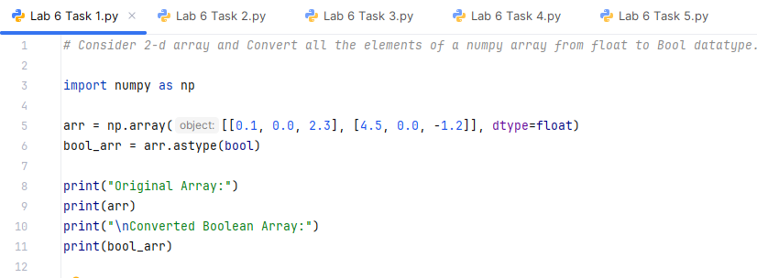

**Explanation:**

astype(bool) converts all non-zero values to True and zero values to False.

**Output:**

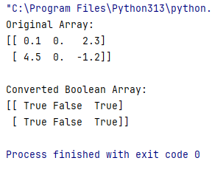

**Task2:**

Write a Python program that uses insert function to add an element to a specific position in a array.

* + add the element 55 at position 2.

### Print the updated array after the insertion.

**Code:**

import numpy as np  
  
arr = np.array([10, 20, 30, 40, 50])  
updated_arr = np.insert(arr, 2, 55)  
  
print("Updated Array after insertion:")  
print(updated_arr)

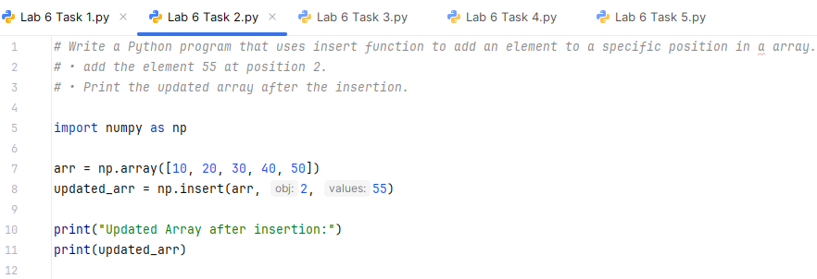

**Explanation:**

np.insert(array, index, value) inserts 55 at position 2 (third element).

**Output:**

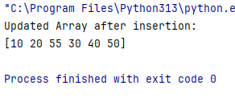

**Task3:**

Generate a sequence of numbers in the form of a numpy array from 0 to 100 with gaps of 2 numbers, for example: 0, 2, 4

**Code:**

import numpy as np  
  
sequence = np.arange(0, 101, 2)  
print("Generated Sequence:")  
print(sequence)

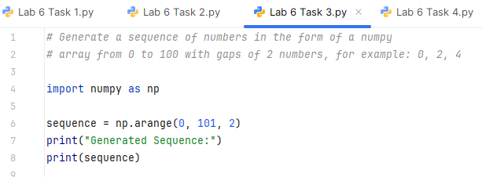

**Explanation:**

np.arange(start, stop, step) generates numbers from 0 to 100 with a step of 2.

**Output**

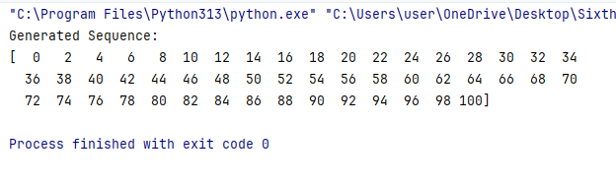

**Task 4:**

Given 2 numpy arrays as matrices, output the result of multiplying the 2 matrices as a numpy array

**Code:**

import numpy as np  
  
A = np.array([[3, 6, 7], [5, -3, 0]])  
B = np.array([[1, 1], [2, 1], [3, -3]])  
  
*# C = np.dot(A, B)*C = A.dot(B)  
  
print("Matrix Multiplication Result:")  
print(C)

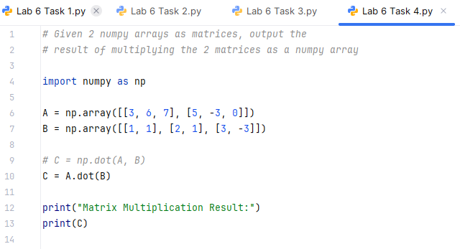

**Output:**

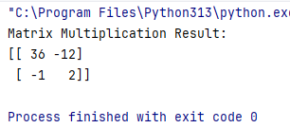

**Task5:**

Consider a 1-d array and check whether the specific number is present or not?

**Code:**

import numpy as np

arr = np.array([10, 20, 30, 40, 50])

num = 60 # Number to check

if num in arr:

print(f"{num} is present in the array.")

else:

print(f"{num} is NOT present in the array.")

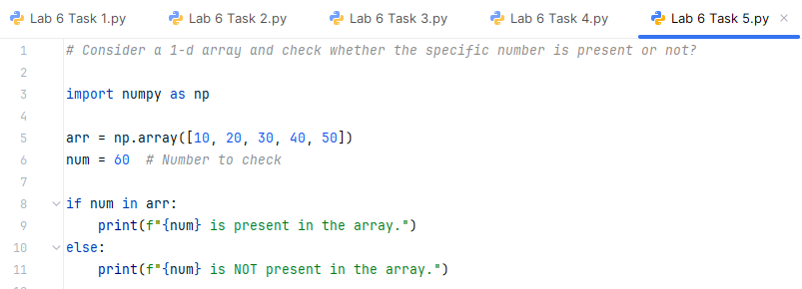

**Output:**

